19.44: For each process, 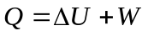. No work is done in the processes ab and dc, and so 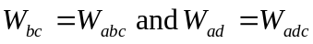, and the heat flow for each process is: for 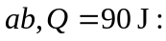for for Q = 350 each process, heat is absorbed in each process. Note that the arrows representing the processes all point the direction of increasing temperature (increasing U).

